Horiba Jobin Yvon Inc.

3880 Park Avenue, Edison, New Jersey 08820-3012, USA
Tel: +1-732-494-8660 Fax: +1-732-549-5125


Troubleshooting LabVIEW VIs for HORIBA Jobin Yvon CCD COM objects

Before Starting the LabVIEW Vis for HORIBA Jobin Yvon’s CCDs, make sure SynerJY or the SynerJY-SDK has been installed on the computer.

If the VIs for Symphony CCDs crash on the first execution of the system, the following procedure should be performed on each sub-VI in the HORIBA Jobin Yvon Symphony VI library, Global_Lib.LLB. After all of the sub-VIs have been re-linked and saved, the Symphony VIs should work correctly.

- Start LabVIEW and open the sub-VI
- Click on the Window menu and select ‘Show Block Diagram’
- Locate the first ActiveX Property Node in the sub-VI

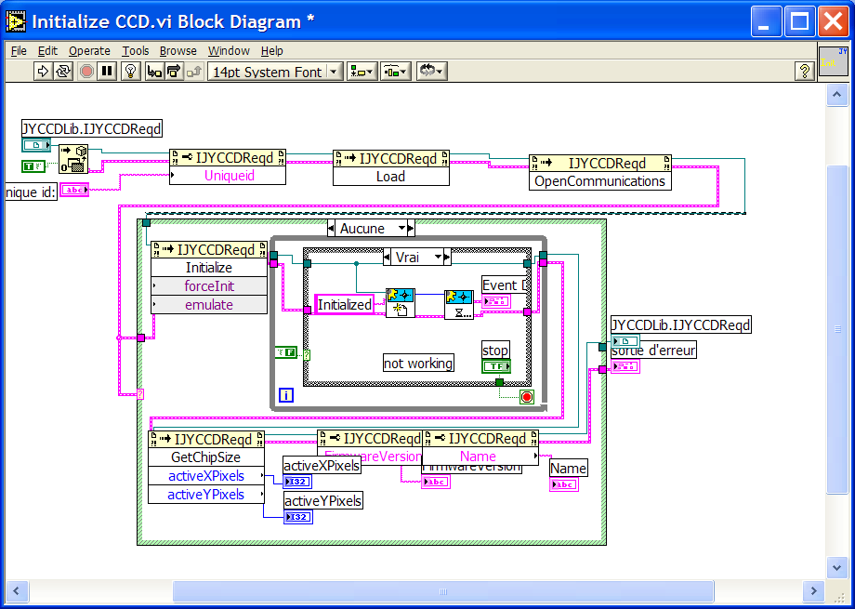
Active X Property Node

- Record the current property of the Property Node. Click on the Property Name to get the list of available properties and change the property to a different property than was originally listed.
- Click on the Property Name again to get the list of available properties and change the property back to the original property that was listed.
- Locate the first ActiveX Invoke Node in the sub-VI

Active X Invoke Node

- Record the current method of the Invoke Node. Click on the Method Name to get the list of available properties and change the method to a different method than was originally listed.
- Click on the Method Name again to get the list of available methods and change the method back to the original method that was listed.
- Save the sub-VI.

If errors continue, turn on the Trace mode to determine where the error is occurring. If there is an Active X Invoke or Property Node or a sub-VI that has not been re-linked, perform the above procedure on that sub-VI.

Other items to check:

- The user has selected a valid Device and UniqueID in the top level VI.
- If the user has modified the VIs, make sure the user is passing the ActiveX Ref Number and Error cluster to each of the sub-VIs after the CCD has been initialized.

